CS 6603: AI, Ethics, and Society

Written Critique: Ethical Autonomous Vehicles

Cleo Zhang

yzhang3761@gatech.edu

***Abstract—*** This written critique addresses ethical considerations in the driving decision that autonomous vehicles would make in extreme cases, evaluating the Mercedes, Tesla and other predetermined scenarios from the perspectives of humanist, protectionist and profit.

# three ethical principles

By tackling the downloaded software with the school bus scenario and watching through the lectures, I can summarize the three “moral judgment” algorithms below:

* Humanist: the driving decision prioritizes human life and safety above all else and minimizes harm to passengers and other road users, even if it means sacrificing the car.
* Protectionist: the driving decision prioritizes property protection, minimizing the damage to the car itself, even if it means putting human lives at risk.
* Profit: the driving decision is made to prioritize financial gains, even if it means putting human lives or property at risk.

The discussion of the following cases will be based on this section's understanding of the given ethical principles.

# Mercedes

This claim falls under the Protectionist sector as Mercedes-Benzes prioritizes saving the people inside the car, and therefore the car itself, above all else.

If I replaced the object of interest with another self-driving car running the Protectionist algorithm, a more severe accident may happen. For example, if I selected Protectionist and replaced the school bus with another self-driving car, two cars may make the same decision to avoid car damage and the driver's death. However, this decision may lead to an unavoidable collision and cause more deaths instead, as shown in *Figure 1*.

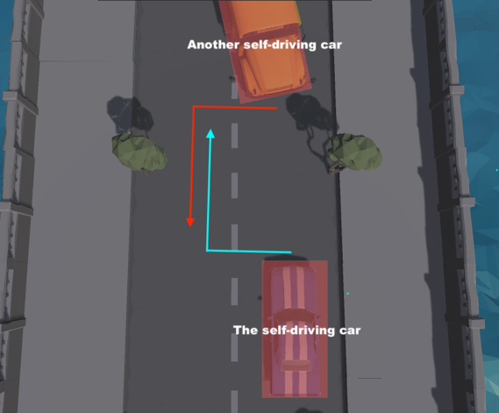

1. Replaced the school bus with another self-driving car.

This outcome would change positively if self-driving cars could communicate with one another. In *Figure 1*, if the vehicle on the top knew the other car would turn left, it may keep driving straight to avoid a frontal collision.

Vehicle-to-vehicle communication can lead to potential data privacy issues. For example, you wouldn't want every vehicle on the road to have access to your driving data. The scale of vehicle-to-vehicle communication data can be massive, so finding a technical solution to solve these potential problems would be challenging.

# Tesla

Tesla’s program is closest to Humanist since it fully respects the driver's own will and would not retaking control of the wheel. However, what would happen depends on the principle the driver follows. This design places the responsibility for potential accidents on the driver himself.

# What if your self-driving car must operate in multiple countries

The car should automatically allow the human to switch from one ethical setting to another. Even better, the vehicle may allow drivers to personalize the ethical setting of the car to better align with themselves. The reason is those moral judgment standards may differ in different countries and cultures, so it is unreasonable to set the ethical setting of vehicles to be the same.

# newest self-driving startup

If the school bus scenario is selected, the traffic rule(s) that the self-driving car violates and the harmed individuals are shown in *Table 1*.

1. Violated Traffic Rules and individual at harm.

|  |  |  |
| --- | --- | --- |
|  | Violated Traffic Rules | Placed at harm if follow all the rules |
| humanitarian | does not violate any traffic rule | The car and its driver; school bus and its passengers (children death risk 2%). |
| protectionist | cut the lane and then drove reverse | The car and its driver; school bus and its passengers (children death risk 2%). |
| profit-deployed | cut the lane. | The vehicle, the driver, the school bus and its passengers (children death risk 2%). |

If the self-driving car follows all the traffic rules, it has to drive straightforwardly and have a frontal collision with the school bus. Passengers on the school bus and the self-driving vehicle will have mild injuries even if the crash odds are 100%.